In this lesson teacher want to quickly show you how to get started in animating with a simple animation in neutron that is a very basic intro video and then wwe are goig to talk abiut the timeline in neutron
We will talk about frame and keyframes and teacher will sho us how to create a very simple nimation
The big black box showing the video is actually viewpoint
So we want to put an object in here tht we can animate
So go to left section(that is toolbar) of the natron
and then click on Draw tool in toolbar and then in submenu choose rectangle
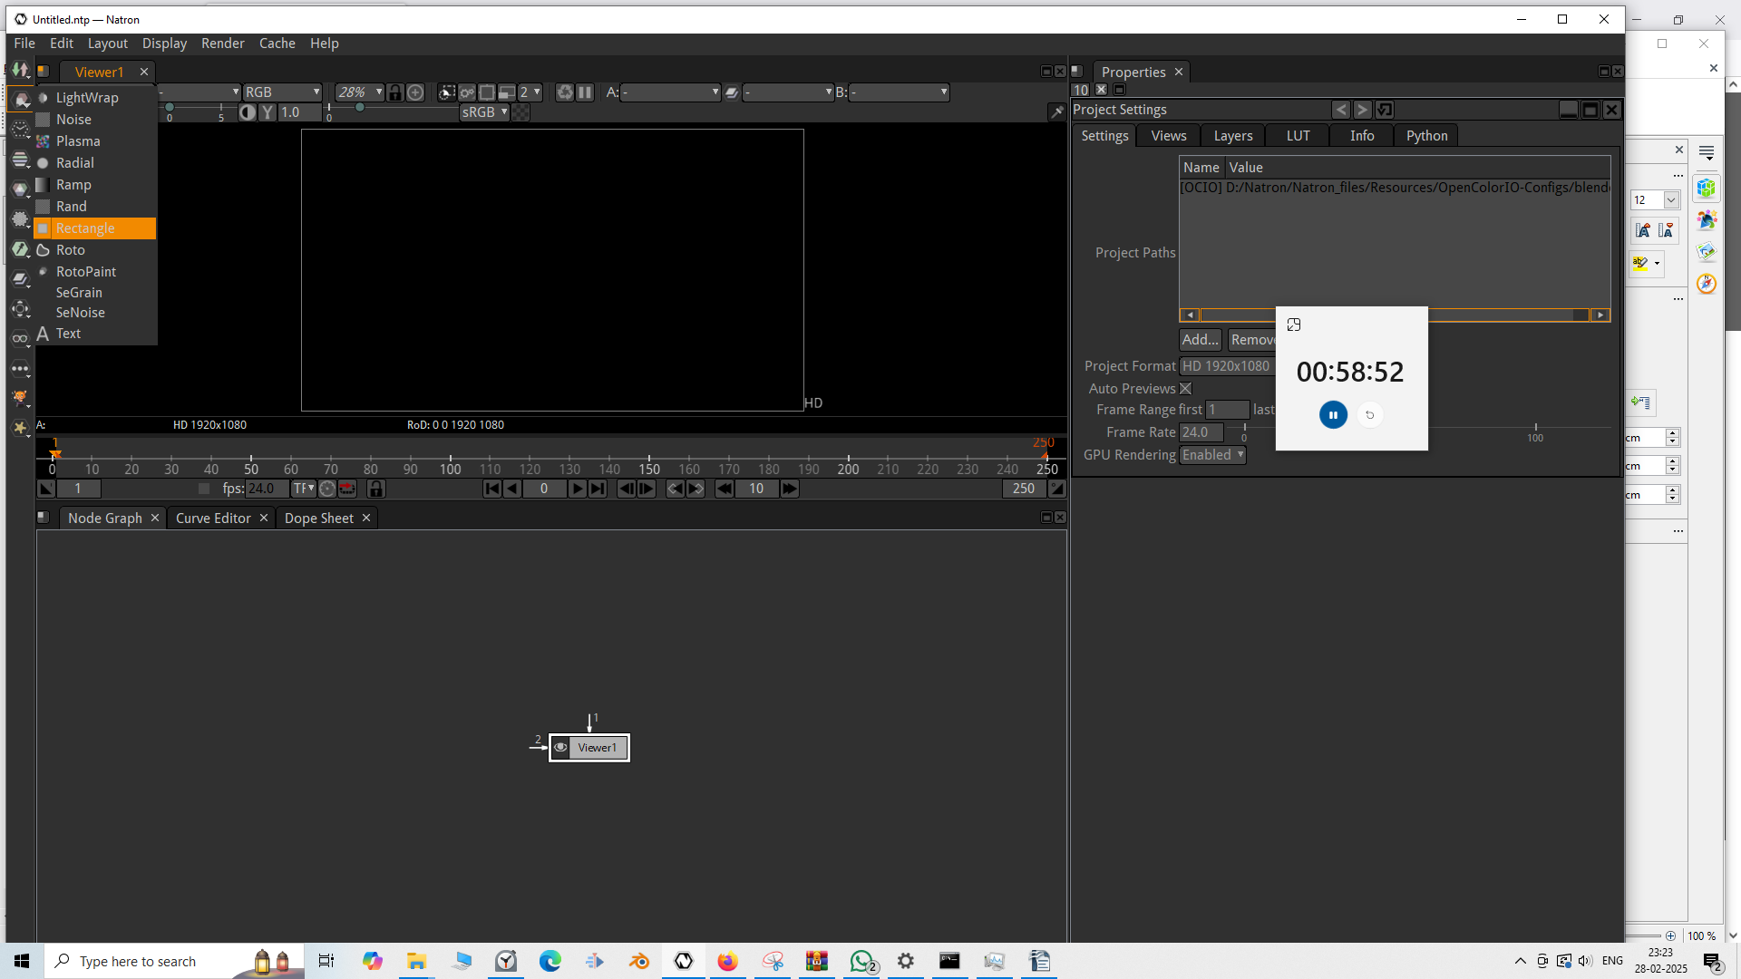
and Now there will be rectangle node connected to Viewer node
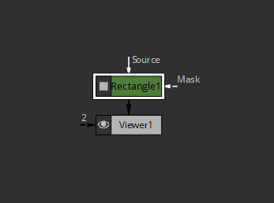
Now since viewer node is connected to Rectangle node

The viewer window will be like this

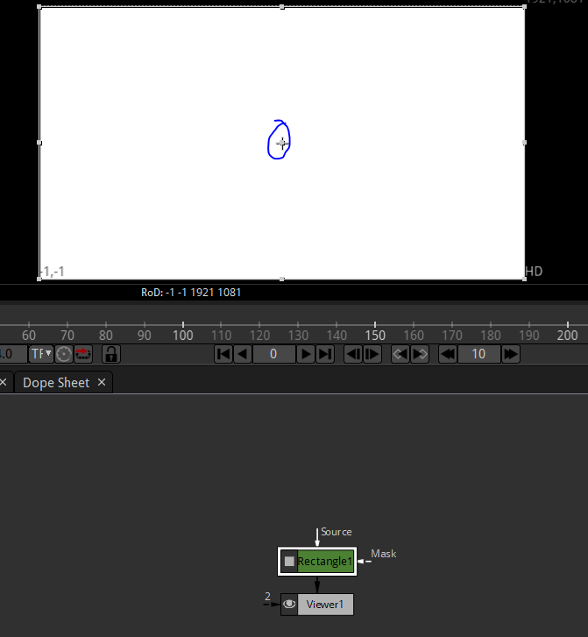
You can click on the marked area to darg it around
you can resize it from edges and eevenly from corners

Now you can see the rectangle1 property in the property window

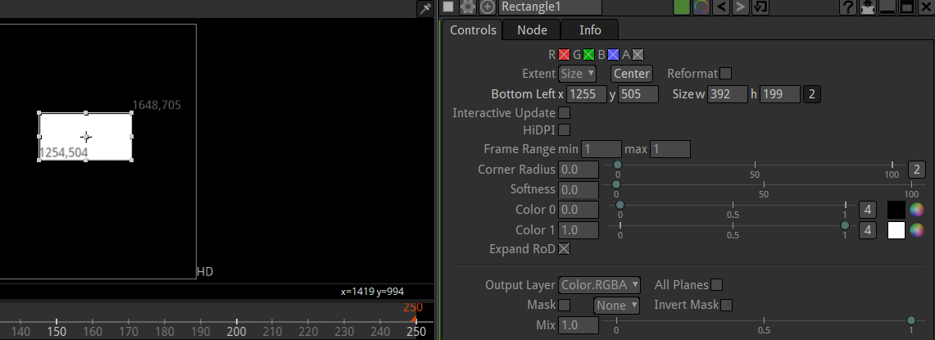
We measure the positrion of the editor from the botom left pont of the rectangle
so you can see its position in bottom Left property
and see the size in size property

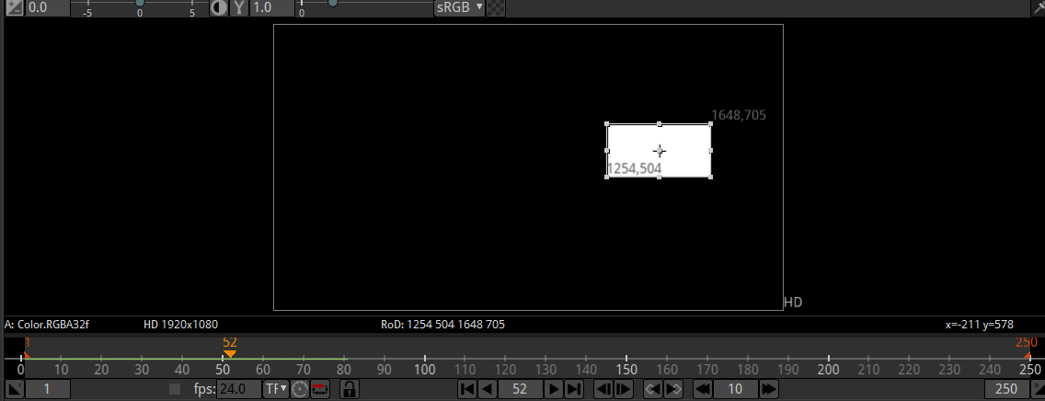
Now when we play the video by pressing the playbutton

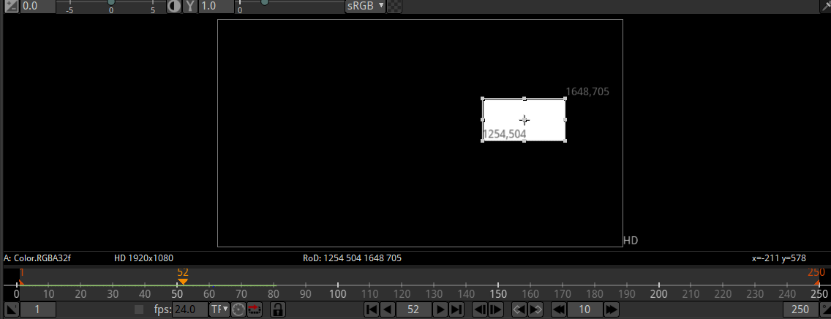
then the playhandle move and with it green line moves and aboive the playhead the frame number it is curently in will be shown
after it reches th end it will restart and keep playing

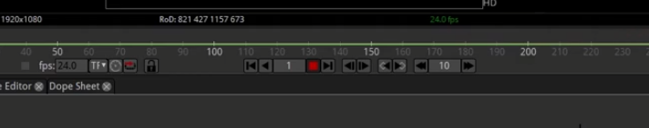
Press on red button to stop it

Now we need to give moving animation to the rectangle we need to tel natron tell teh software where we wnat this box to move to
Now we want to animate it from the mddle of the screen so we place the rectangle in the middle of the screen
and move it to the playhead to the first frame by clicking on the marked below

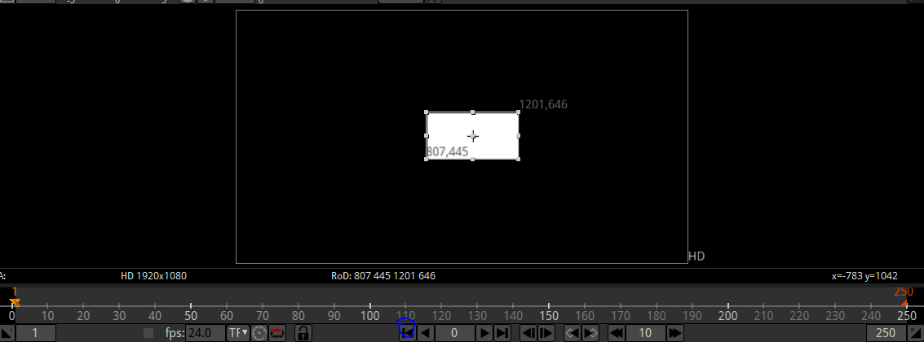
4:16

or you can go to type the frame number in the marked below

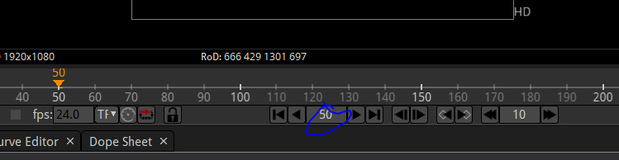
whatever frame number you type and press enter and click on any area and it is deselected then the playhead will reach that frame

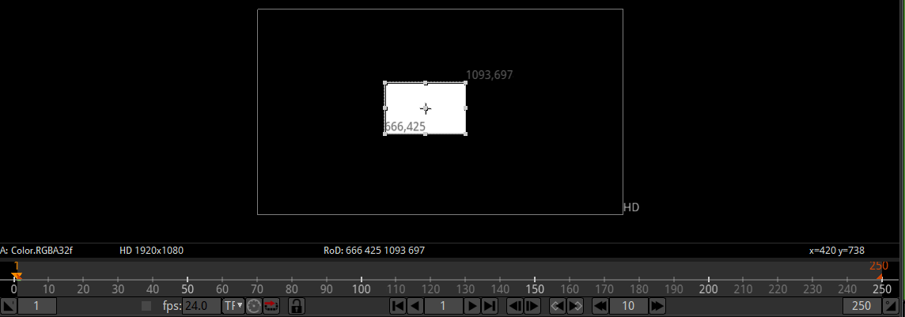
Now we come to frame one npw it will look like above screen
Now this frame is the starting point of our animation
Now to make it move we will set a keyframe
To set it to go to the property you want to animate of your rectangle .In this case we want to animate its position so we select the rectangle node in node graph and then in properties window right click on the bottom left property and then in submenu choose
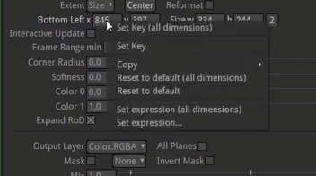
Set Key (all dimension) for all the x,y,z(I think so) but if you want to set it for the dimension in which you have right cliked then click on Set Key

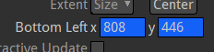
Now these input fields color are changes
and in timeline whenever the playhead is on the frame one now it will be tirned into blue color as shown below

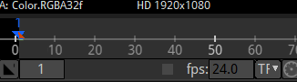
No it tels us that it is a keyframe now
Now if you move to frame 50 or any other frame then it will be orange in color
which indicates it is just a frame as shown below

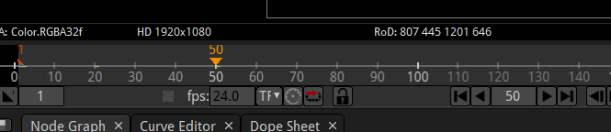
now if you drag the rectangle and but the playhead remainfs in that orange frame

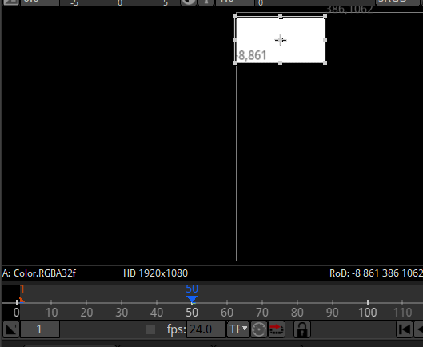
Now this orange frame will be converted to dark blue frame means it is a keyframe now so there
are to keyframes now one is at frame 1(rectangle preset in the center of tehscreen) and another is at frame 50(rectangle persent in the top left part of the screen ) and the inpu firld of bottom left is blue now
So a keyframe is created at 50 frame
These keyframes creates an automatic transition between different values position of rectangle between both the keyframes In between the keyframes the frames willl have different positions value
which when we play the video then frame by frame then rectangle will look that it is being transitioned from one position to another which create an animation
Now we g to 100 frame
and position the rectangle as shown below
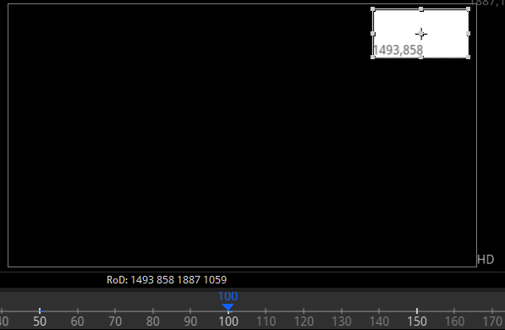
Now the rectange will go from center to tope left and then from top left to top right

Now in 134 frame we set it to bottom right now it willmove slighly faster because frame between 100 and 134 is 34 frame which is very less in number

When you are on the frame then the field which nis being animated is light blue in color as shown below

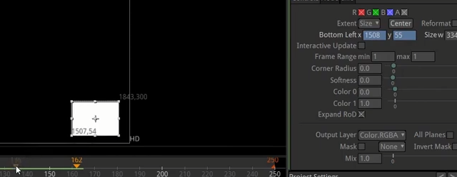
If you change there values by dragging the rectangle or even in the values in the field
I willl not go in detail because next is self explanatory
You can play along all the properties and animate ansd explore the software
We will do a lot more animation in the next lessons
We ar goint o show you how to export it into a video project or series of picture whatever you wanted but just play with that little bit
you can play with color settings and other setting you can animate as weel Explore it you can combine differetnt animation

